Question 2, Assignment 1

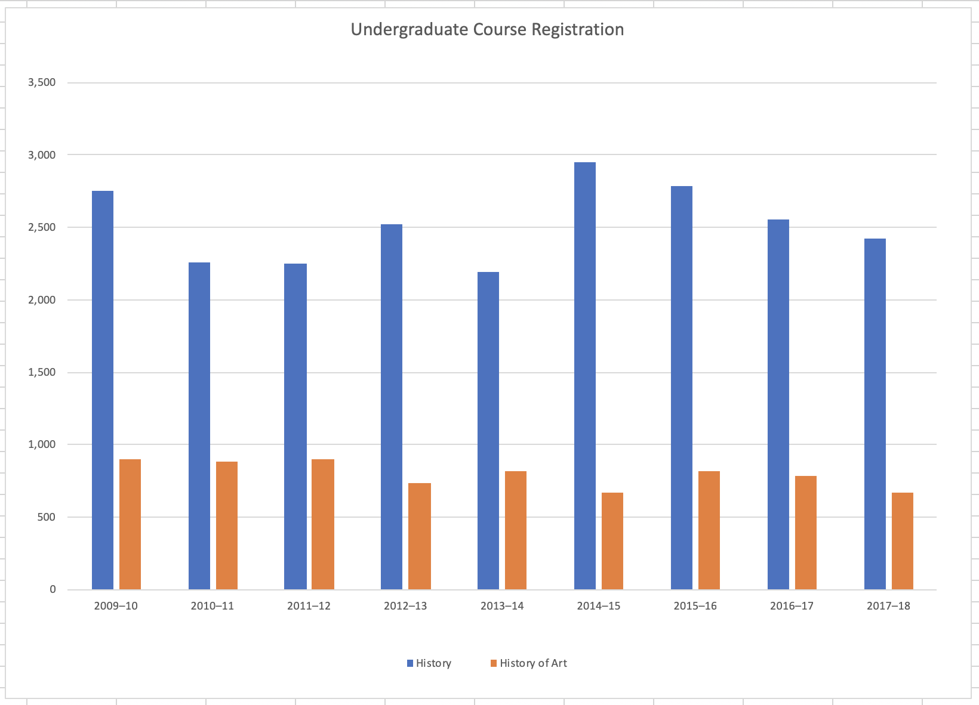1.

2. The years were plotted along the Y axis to show change over time, whereas the enrollment data were measured along the Y axis to show variation in the data. History and History of Art enrollments were juxtaposed side-by-side to show the difference in their respective popularity. The two departments have colors which contrast strongly to create a clearly discernible division between their heights.

3. A bar chart is the best style of visualization because it clearly shows the difference in heights. Ideally, the Y axis would have more tick marks so as to show more precise measurements, but a bar chart nonetheless is the best option to show change over time as well as relative difference between two datasets.

1.

2. Each of the three datasets was broken into a piece of the overall graph to show their relation to each other as well as to the total. The percentages have been derived from the original data, and the original data is not directly visualized.

3. A pie chart is the best type of visualization because it shows a whole as well as its parts. By creating a pie chart, I was able to derive percentages without having to intentionally calculate anything, and it shows the relative sizes of each dataset as compared to a larger whole, which gives the data perspective and new meaning.